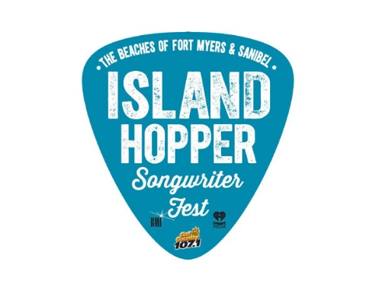

July 13, 2020
Contacts: Francesca Donlan, Jackie Parker 239-338-3500

Lee County Visitor & Convention Bureau
MEDIA ALERT
Songs from the Sofa concert stays in tune with virtual performance by Maia Sharp

What: The Lee County Visitor & Convention Bureau, iHeartMedia and Cat Country 107.1 proudly present Songs from the Sofa hosted by DJ Mike Tyler from Cat County 107.1. Its third virtual concert will feature live music, interviews and stories behind the songs.

Who: Maia Sharp, a BMI singer-songwriter, has worn many hats. She has had her songs recorded by Bonnie Raitt, Trisha Yearwood, Keb’ Mo’, Cher, Edwin McCain, David Wilcox, Art Garfunkel, and many more. She produced Edwin McCain's last album Mercy Bound (429 Records) and, most recently, two songs for Garfunkel's retrospective double album The Singer (Sony). And through it all, Sharp has continued to record her own albums. Her latest duo project is Roscoe & Etta with writing/production partner Anna Schulze. Sharp has appeared on NPR's "All Things Considered," "CBS Early Morning" and the "Today" show, to name a few.

When: 8 p.m. Thursday, July 16

Where: Island Hopper Songwriter Fest Instagram page

Why: To celebrate music with one of the songwriters who will perform at the seventh annual Island Hopper Songwriter Fest, taking place Sept. 18-27, on Captiva Island, historic downtown Fort Myers and Fort Myers Beach. The festival is still scheduled and will include best practices in compliance with CDC guidelines. For now, Songs from the Sofa should provide an exciting way to experience a quality performance in your own home.

For more information: Please visit https://www.island-hopper.fortmyers-sanibel.com/

-30-

Island Hopper is produced by the Lee County Visitor & Convention Bureau, iHeartMedia,
Cat Country 107.1 and BMI, the largest music rights organization in the U.S. Visit IslandHopperFest.com or access the media tool kit. Follow the festival hashtag #islandhopperfest as well as the event’s Twitter, Instagram and Facebook feeds.

