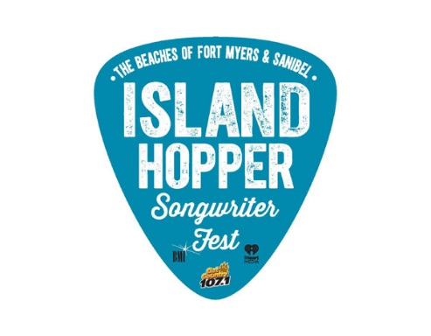

Aug. 12, 2020
Contacts: Francesca Donlan, Jackie Parker 239-338-3500

Lee County Visitor & Convention Bureau
MEDIA ALERT
Songs from the Sofa concert stays in tune with virtual performance by Dave Pahanish

What: The Lee County Visitor & Convention Bureau, iHeartMedia and Cat Country 107.1 proudly present Songs from the Sofa hosted by DJ Mike Tyler from Cat County 107.1. Its fourth virtual concert will feature live music, interviews and stories behind the songs.

Who: Dave Pahanish, a BMI singer-songwriter from Pittsburgh, Pa, who moved to Nashville in 2007 and has written songs for Toby Keith, Jimmy Wayne, Tim McGraw, Keith Urban and many others. He has had three No. 1 singles on the billboard country charts including Keith Urban's "Without You," Toby Keith's "American Ride," and Jimmy Wayne's, "Do you Believe Me Now." As a performing songwriter, Dave has toured extensively.

When: 8 p.m. Thursday, Aug 20, 2020

Where: Island Hopper Songwriter Fest Instagram page

Why: To celebrate music with one of the songwriters who will perform next year at the annual Island Hopper Songwriter Fest, taking place Sept. 17-22, 2021 on Captiva Island, historic downtown Fort Myers and Fort Myers Beach. Songs from the Sofa will provide an exciting way to experience a quality performance in your own home.

For more information: Please visit https://www.island-hopper.fortmyers-sanibel.com/

-30-

Island Hopper is produced by the Lee County Visitor & Convention Bureau, iHeartMedia, Cat Country 107.1 and BMI, the largest music rights organization in the U.S. Visit IslandHopperFest.com or access the media tool kit. Follow the festival hashtag #islandhopperfest as well as the event’s Twitter, Instagram and Facebook feeds.

