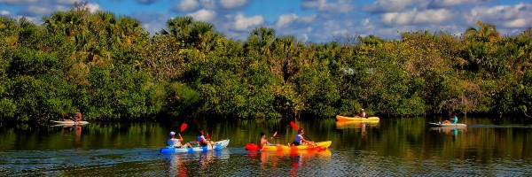

What To Do the week of Feb. 7-13, 2022

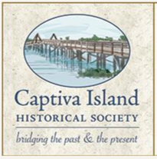
Monday, Feb. 7

Open-air Cinema, McCarthy's Marina, Captiva Island
The Captiva Island Historical Society invites you to watch
"Our Mailboat Santiva" and "South Seas: Captiva's Enduring Paradise" from your golf cart or folding chair outside in the parking lot of McCarthy's Marina at 7 p.m. Monday. $12, reservations recommended. McCarthy's Marina, 11401 Andy Rosse Lane, Captiva, 239-472-2323, captivaislandhistoricalsociety.org

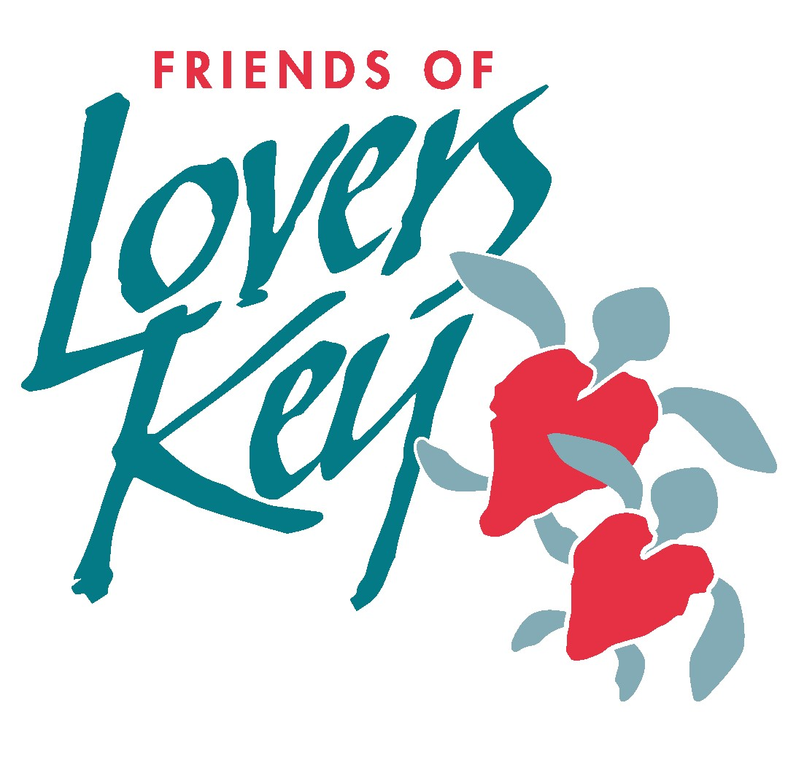
Tuesday, Feb. 8

Fishing clinic, Lovers Key State Park, Fort Myers Beach
Join park naturalists Bob and Valerie Lindner to learn more about fishing in Southwest Florida. The 10 a.m. program is free with paid park entry, reservations required. Lovers Key State Park, 8700 Estero Blvd., Fort Myers Beach, loverskey.eventbrite.com

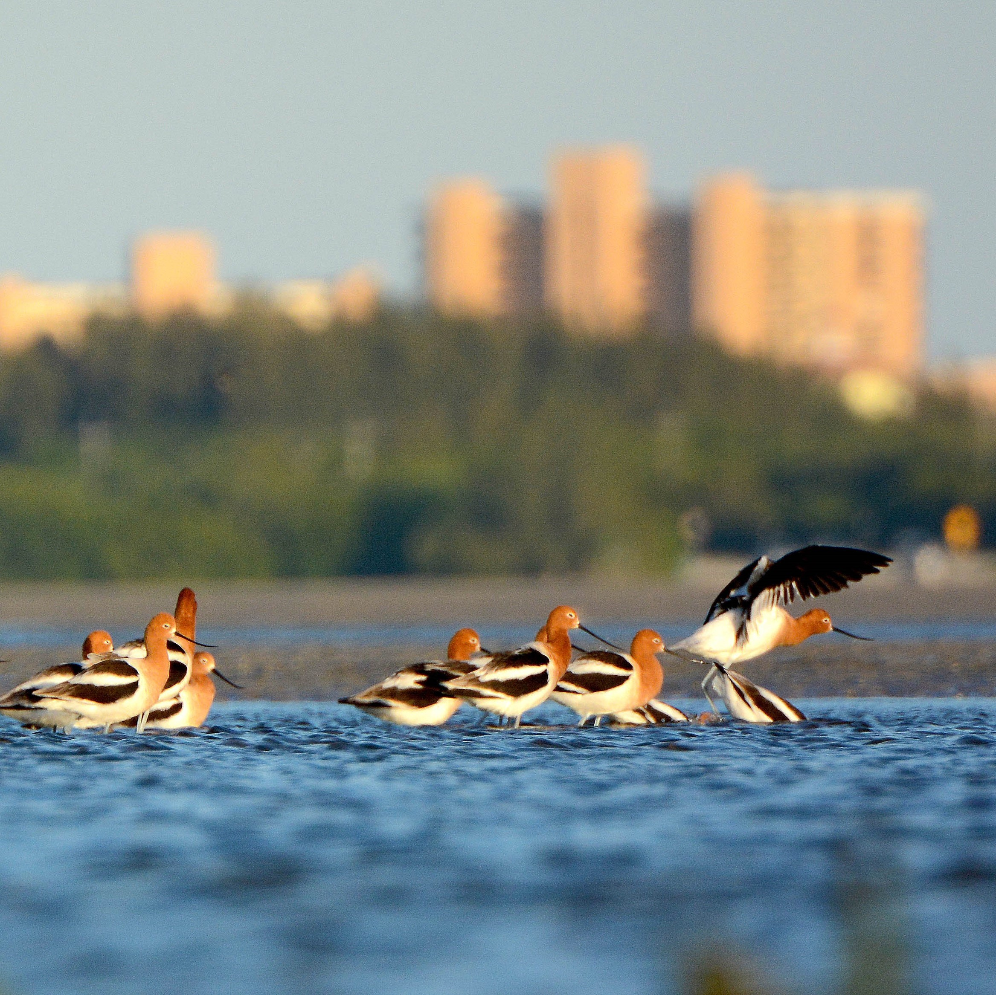
Wednesday, Feb. 9

Wednesday guided walks, San Carlos Bay Bunche Beach Preserve
Free guided beach walks at 9 a.m. will continue through the end of April. The 718-acre property is an Old Florida natural tidal wetland that ranges from a sandy beach to mangrove forests to salt flats and wildlife. Parking is $2 an hour and the meeting point for the walks will be the southernmost end of John Morris Road in the parking lot. San Carlos Bay Bunche Beach Preserve, 18201 John Morris Road, Fort Myers, 239-533-7275, leegov.com/parks

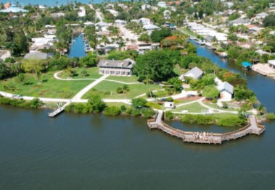
Thursday, Feb. 10

Cool Calusa tools, Mound House, Fort Myers Beach
Learn to hunt, fish and make masks and pottery, just like the Calusa. $5, in addition to admission, for families with children ages 6 and older. 10 a.m. Thursday and Saturday. Mound House, 216 Connecticut St., Fort Myers Beach, moundhouse.org

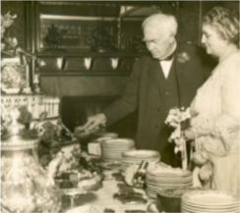
Friday, Feb. 11

Happy Birthday, Thomas Edison, Edison and Ford Winter Estates, Fort Myers
Celebrate the inventor's 175th birthday with performances by the Edison Park Creative and Expressive Arts School. Event begins at 10 a.m. and cake will be served. The party is a free public event with limited seating. Edison and Ford Winter Estates, 2350 McGregor Blvd, Fort Myers, 239-334-7419, edisonfordwinterestates.org

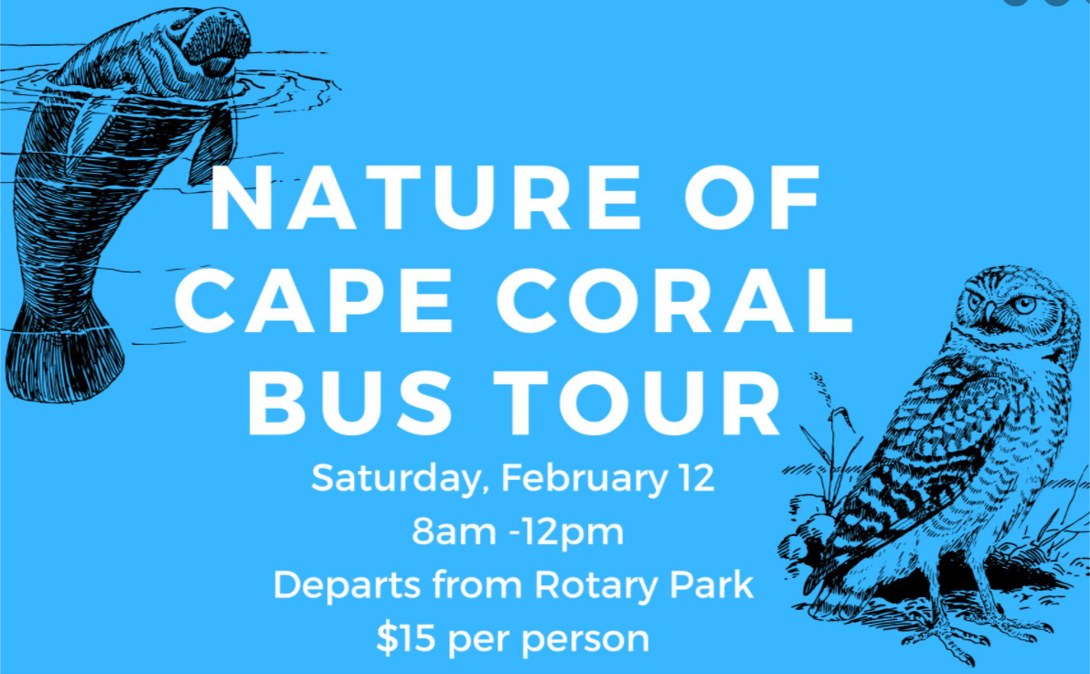
Saturday, Feb. 12

Nature of Cape Coral Bus Tour, Cape Coral
Join the Cape Coral Friends of Wildlife on this unique tour that includes possible sightings of burrowing owls, manatees, osprey, eagles, scrub jays, hawks and more. Registration required, $15, 8 a.m.-noon. Rotary Park,
5505 Rose Garden Blvd., Cape Coral, 239-549-4606,
Facebook event and Nature of Cape Coral Bus Tour

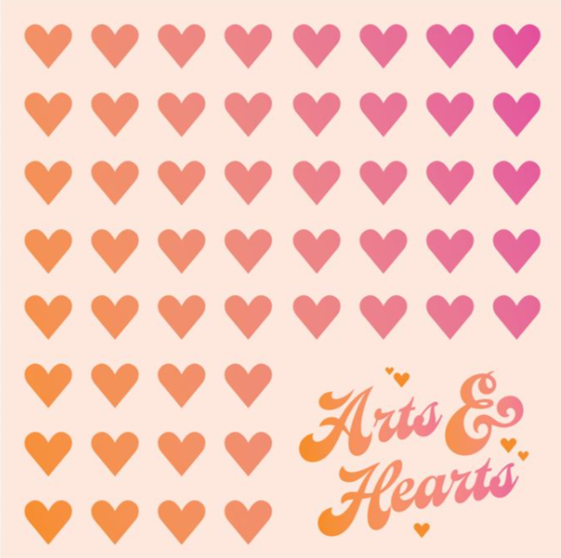
Saturday, Feb. 12

Arts & Hearts, Edison Mall, Fort Myers
This crafty events will include wine glass painting, treats, sips, giveaways, a raffle, live music and more. At the Kids Yard by Dillard's Entrance F and G. Noon-3 p.m. Edison Mall, 4125 Cleveland Ave., Fort Myers, 239-989-1933, shopedisonmall.com

Saturday and Sunday, Feb. 12-13
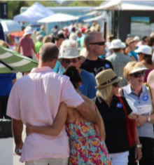
Bonita Springs National Art Festival, Bonita Springs Meet and buy from hundreds of artists displaying a variety of fine art and crafts. 10 a.m.-5 p.m. Saturday and Sunday. Riverside Park, 10450 Reynolds St., Bonita Springs, artcenterbonita.org/artfest

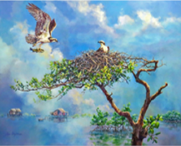
Saturday and Sunday, Feb. 12-13

Pine Island Art Association Show and Sale, North Fort Myers
This show presents current work by many of the area's most experienced and talented artists. 10 a.m.-4 p.m. Saturday and Sunday. North Fort Myers Recreation Center, 2000 N. Recreation Parkway, North Fort Myers, pineislandart.com

Ongoing events

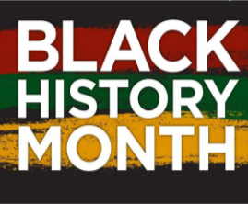
Celebrate Black History Month, Captiva Memorial Library, Captiva Island
Browse the Black History Month book display, complete activity sheets and make a peace dove craft. 9 a.m.-5
p.m, Feb. 8-12. Captiva Memorial Library, 1560 Chapin Lane, Captiva, 239-479-4636, leelibrary.librarymarket.com

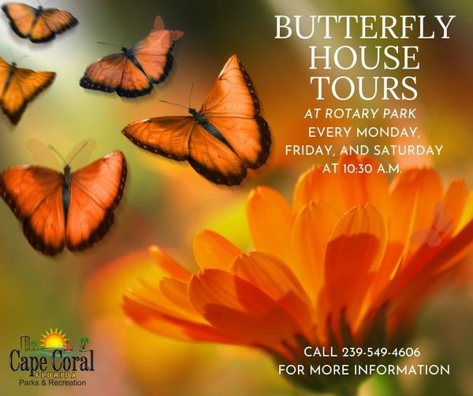
Butterfly House tours, Monday, Friday and Saturday, Cape Coral
The Tom Allen Memorial Butterfly House is home to many native Florida butterfly species, including the zebra longwing, the state butterfly. Guides explain the different butterflies, their caterpillars and host plants. Donations are accepted. 10:30 a.m. Monday, Friday and Saturday. Rotary Park, 1340-1372 Rose Garden Road, Cape Coral, 239-549-4606, ccfriendsofwildlife.org/tom-allenmemorial-butterfly-garden
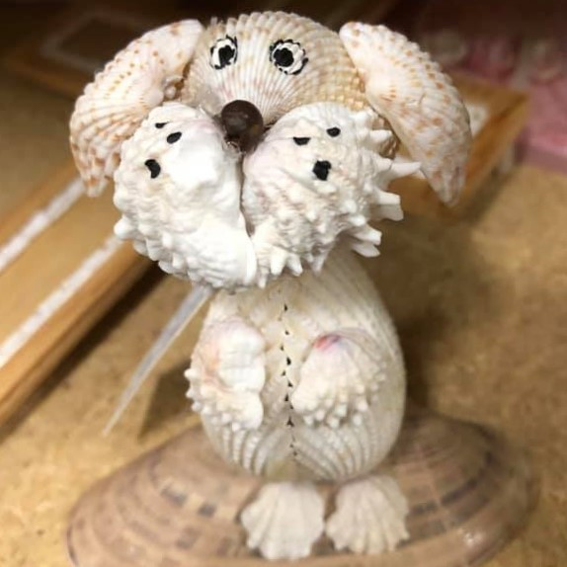
Mondays with the Shell Crafters, Sanibel Island Free class, supplies cost between $3-$5 and the shell crafters will help you make something special. 9 a.m.-3 p.m., class begins at 10 a.m. The Community House, 2173 Periwinkle Way, Sanibel, 239-472-2155, sanibelcommunityhouse.net

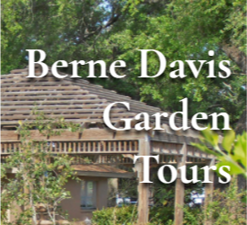
Tuesday & Thursday tours at Berne Davis Gardens, Fort Myers
The Berne Davis Gardens are open 10 a.m.-1 p.m. every Tuesday and Thursday through May. The gardens feature bromeliads, hibiscus, rare and tropical fruit, bonsai display and more. Guided tours available. Berne Davis Gardens, 2166 Virginia Ave., Fort Myers, 239-332-4942, fmlcgardencouncil.com
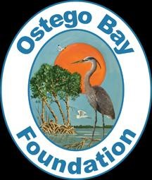
Working waterfront tours of San Carlos Island shrimp fleet, Ostego Bay Foundation, Fort Myers Beach Tours offered from 9 a.m.-noon Wednesdays give a close-up view of the shrimping industry, plus a visit to the Marine Science Center Museum. $20 adults, $10 children. Reservations required. Ostego Bay Foundation, 718 Fishermans Wharf, Fort Myers Beach, 239-765-8101, ostegobay.org

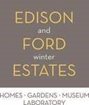
Yoga in the Moonlight Garden, Edison and Ford Winter Estates, Fort Myers
Every Wednesday morning an hourlong yoga class allows you to step away from all of the 21st-century gadgets and focus on the moment. All skill levels welcome. 10-11 a.m. $15 for members, $20 non-members and can be purchased online or at ticket counter. Bring a yoga mat, water and towel. Admission to the site is not included. Edison and Ford Winter Estates, 2350 McGregor Blvd, Fort Myers, 239-334-7419, edisonfordwinterestates.org/calendar/

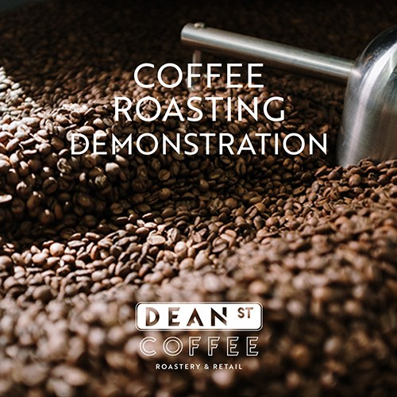
Saturday coffee roasting demonstration at Dean Street Coffee Roastery, Fort Myers
Enjoy an informal talk with the master roaster and see a live, free demonstration of the coffee roasting process. 10 a.m. Saturdays. Dean Street Coffee Roastery, Luminary
Hotel & Co., 2200 Edwards Drive, Fort Myers, 239-314-
3853, luminaryhotel.com/taste

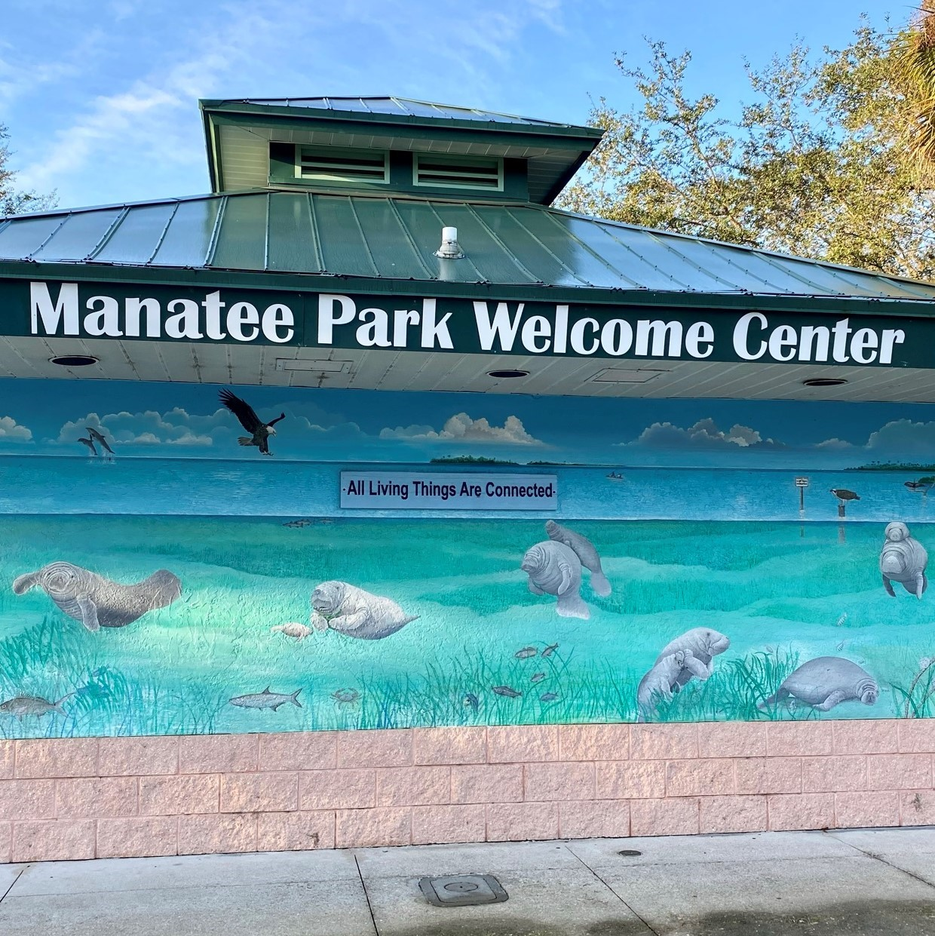
Sunday garden tours at Manatee Park, Fort Myers
A volunteer naturalist leads the tours and participants can learn about the park’s history and the native flora and fauna that reside in some of Florida’s habitats. Optimum viewing for the Florida manatee is now through March. 9 a.m. Sundays through March. Tours meet behind the welcome center. Free with paid parking. Manatee Park, 10901 Palm Beach Blvd., Fort Myers, 239-533-7275, leegov.com/parks/parks/manateepark

Performing arts and exhibits

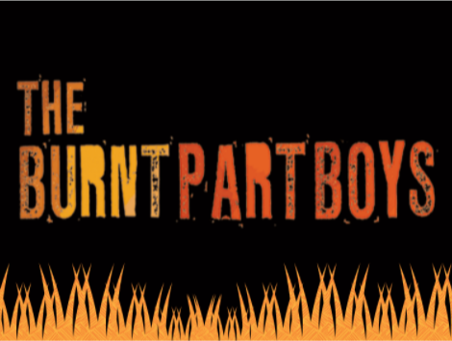
Alliance for the Arts
Southwest Florida Pastel Society Exhibition, through Feb. 26
"The Burnt Part Boys," Feb. 11-12
Alliance for the Arts, 10091 McGregor Blvd., Fort Myers,
239-939-2787, artinlee.org

Barbara B. Mann Performing Arts Hall, Fort Myers
"Dear Evan Hansen," Feb. 8-13
Barbara B. Mann Performing Arts Hall, 13350 FSW
Parkway, south Fort Myers. 239-481-4849,
bbmannpah.com

BIG ARTS, Sanibel Island
Juried show: Creative Ventures, through Feb. 28
"Language Lessons," Feb. 7
Dr. Donald Berwick, "The Moral Determinants of
Health," Feb. 9
Jane Mayer, "Money, Power and Politics and the
2022 Election," Feb. 10
Heart by Heart, Feb. 12
BIG ARTS, 900 Dunlop Road, Sanibel Island, 239-395-
0900, bigarts.org

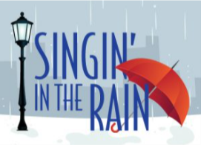
Broadway Palm Dinner Theatre
"Singin' in the Rain," through Feb. 12
"Over the River and Through the Woods," through March 5
Broadway Palm Dinner Theatre, 1380 Colonial Blvd., Fort
Myers, 239-278-4422, broadwaypalm.com

Florida Rep
"Driving Miss Daisy," through Feb. 13
"Into the Breeches," Feb. 8-March 5
Florida Rep, 2268 Bay St., Fort Myers, 239-332-
4488, floridarep.org

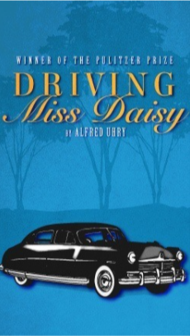

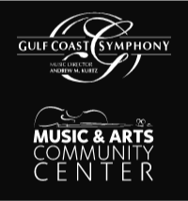
Gulf Coast Symphony
Jazz at the MACC: Latin jazz with Jose Valentine,
Feb. 10
Stars at the MACC: Jodi Benson, Feb. 11
Gulf Coast Chamber Orchestra & Fort Myers Symphonic Mastersingers, Feb. 12
Music & Arts Community Center (MACC), 13411 Shire Lane, Fort Myers, 239-277-1700 Ext. 108, gulfcoastsymphony.org

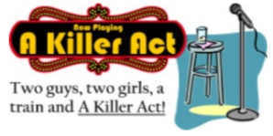
Murder Mystery Dinner Train
"A Killer Act," through Feb. 27
Murder Mystery Dinner Train, 2805 Colonial Blvd., Fort Myers, 239-275-8487, semgulf.com

Sidney & Berne Davis Art Center
Thank God It's Monday, Feb. 7
Exhibit: The Female Spirit, through Feb. 23
Group art show: Women Take Issue, through Feb.
23
Group art show: Her Story, Our Story, through Feb.
23
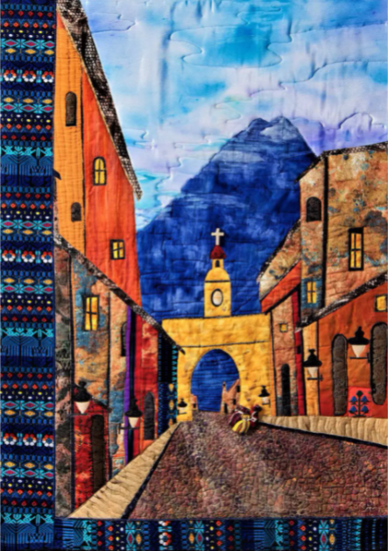
Sidney's Rooftop Sculpture Garden: Rick Costa
Trio, Feb. 11
Jazzy Nights Presents: Dan Miller & Lew Delgatto Quintet featuring Jeremy Davenport, Feb. 11
Sidney & Berne Davis Art Center, 2301 First St., Fort
Myers, 239-333-1933, sbdac.com

Podcast

Shellcast, the podcast that's a beach break for your ears
Listen in, soak up some virtual sun and hear what makes Southwest Florida so special. Shellcast is available wherever fine podcasts are downloaded and at
VisitFortMyers.com/shellcast
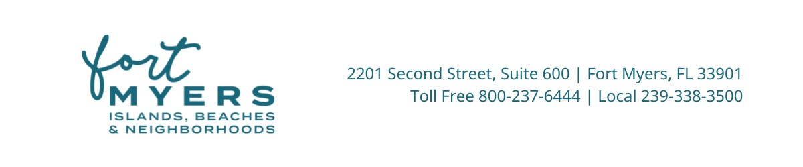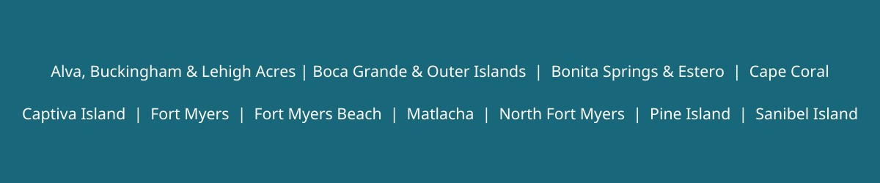
Lee County Visitor & Convention Bureau
2201 Second Street, Suite 600, Fort Myers, FL 33901, USA
Visit our website VisitFortMyers.com to learn more!

